Project ScreenShots:-

1. Users will Register themselves

By giving the following details



Then Click on SEND OTP

[The Otp will be send to your given Email Id]

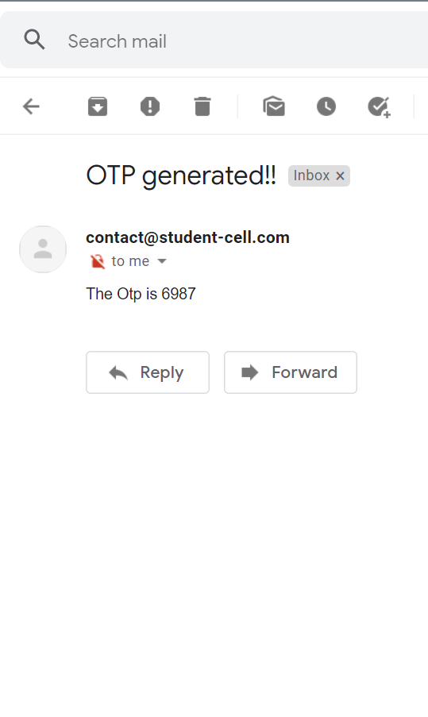

After Entering the Otp, the User will be Successfully Registered

1. After the Registration, Again User Id and Password will be sent to your given Email Id

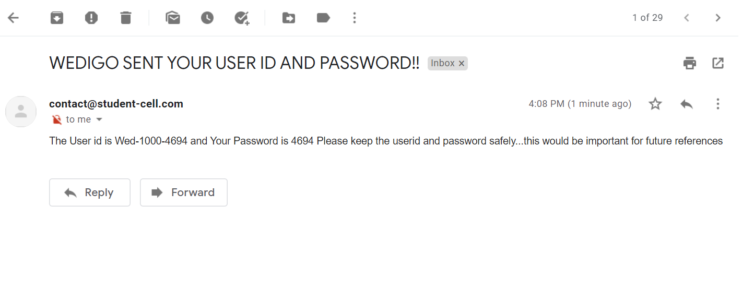

User will keep this User Id and Password for future references.

Now, User will click on Login button to login into website.

1. Login (Enter the mailed User Id and Password)

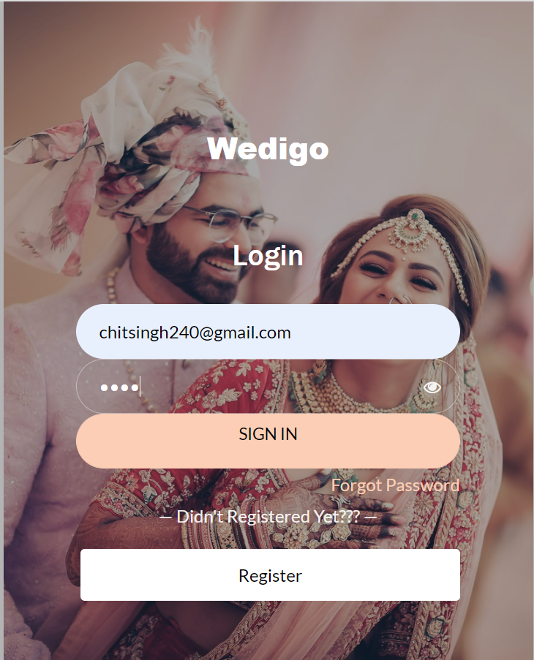

After checking the credentials User will be directed to website.

1. Website Overview-



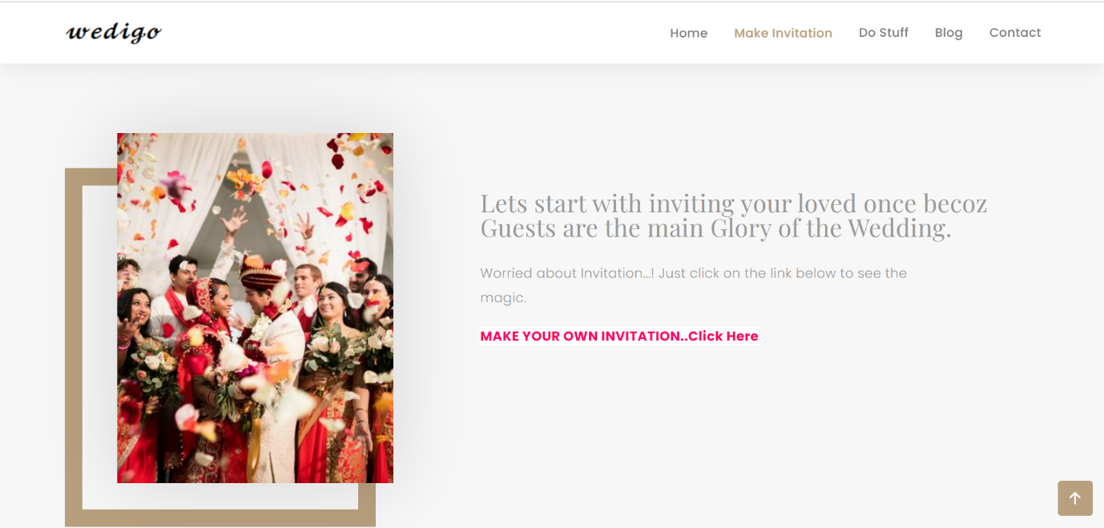

In 2nd page, a link is given in red color which will help the Users to make Invitation Card for wedding.

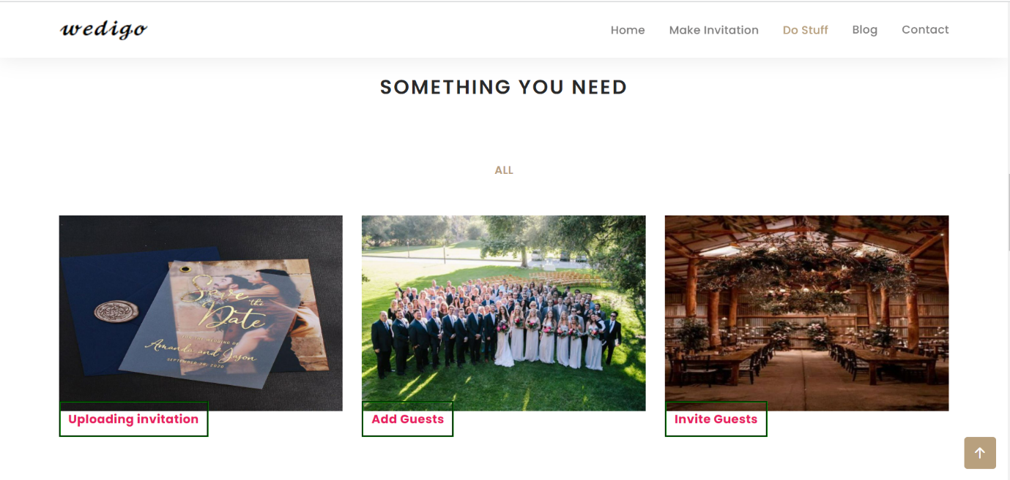

The above page shows Navigation bar includes Home, Make Invitation, Do Stuff, Blog and Contact.

And Something You Need Section is the Section where User can Upload Invitation, Add Guests and Invite Guests

User Will Click On Uploading Invitation.

* 1. Uploading Invitation-



Here, User will enter the Email Id (Same as given during registration)

Select the file user wants to uploads for Invitation.

Click On Upload.

Pop up will be shown saying Successfully Uploaded.





* 1. Add Guests-

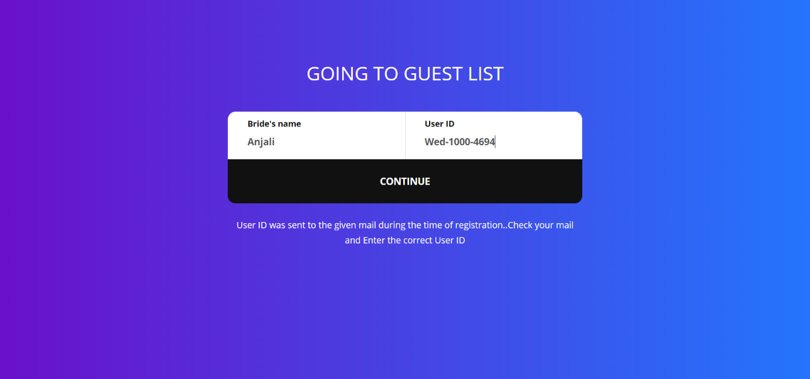

The Above page will be asked the user the Bride’s name and User Id for Login to Add guest Web page.

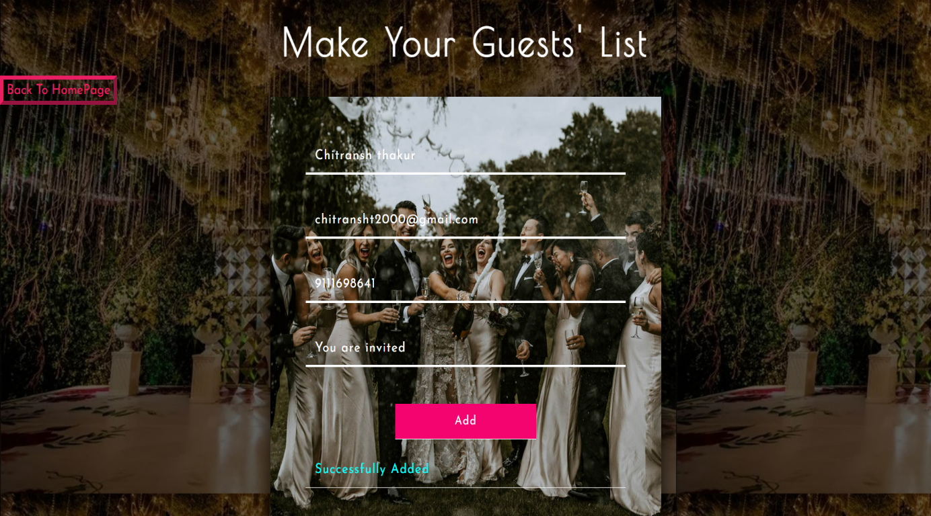

In Make Your Guests’ List User will enter the Guest’s Name, Mobile, Email and Message for Guest.

Then Click on Add button.

Guest will be Successfully added to the Guest list.

* 1. Invite Guests-

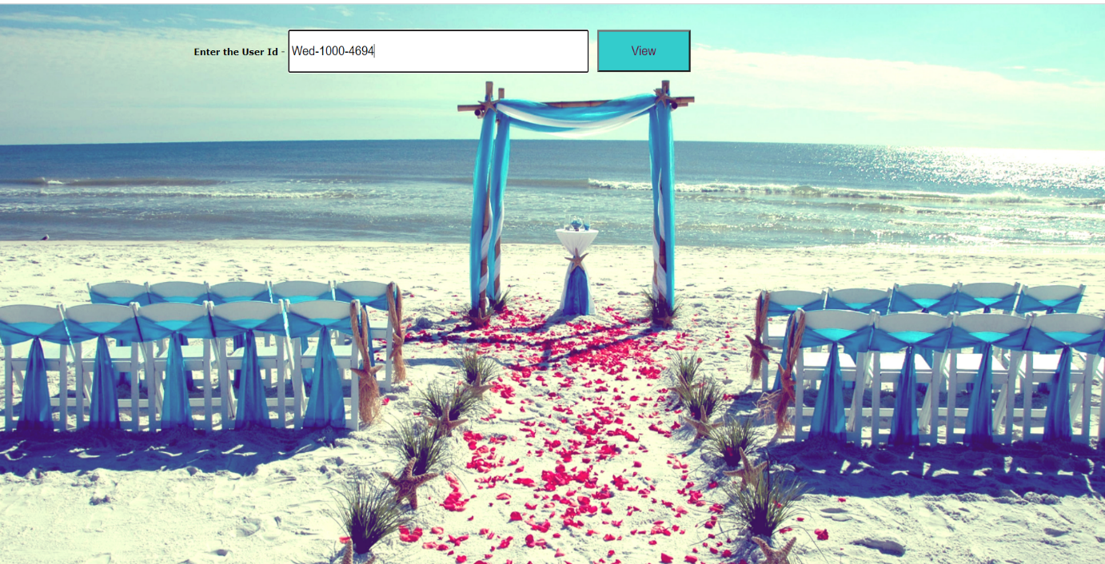

Here User will enter the User Id and Click on View.

After Clicking on View Button the

Guest List will be shown.

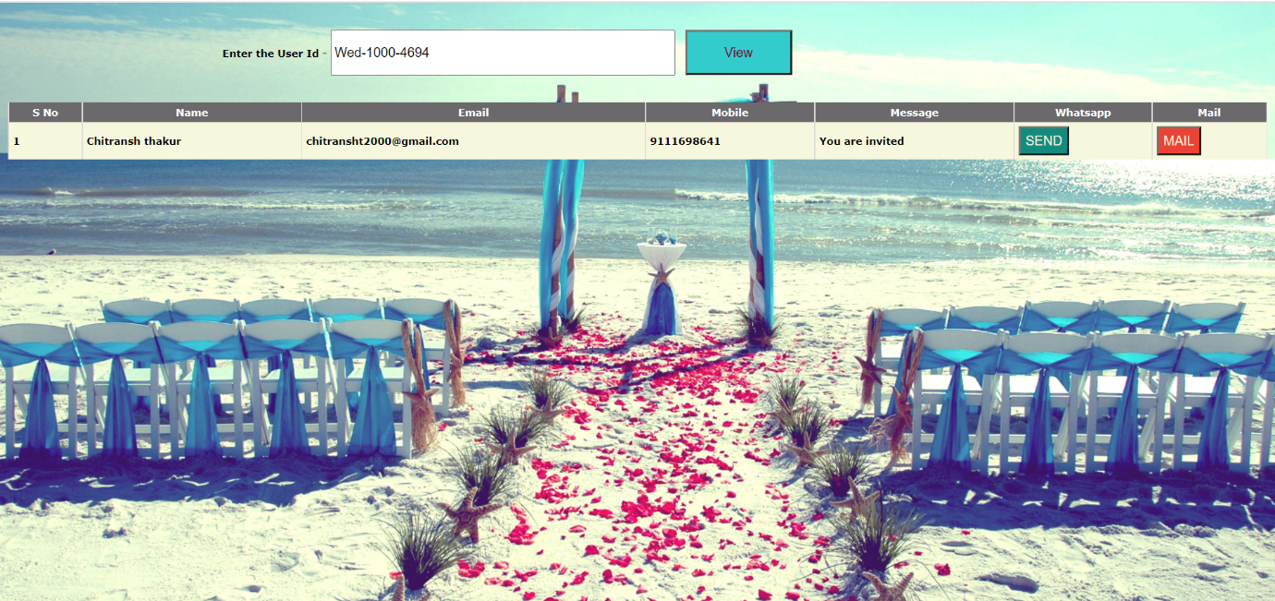

In Grid, User can send whatsapp message or Mail the Uploaded Image to the Guest by just clicking on Send or Mail Button respectively.